Name of Assembly: United Apostolic Church
Type of service: Bible Study
Date: August 19th, 2025
Series Topic: The Works of the Flesh
Lesson 8: Sins of Hostility – Part 6
Scripture Text: Galatians 5:19-21
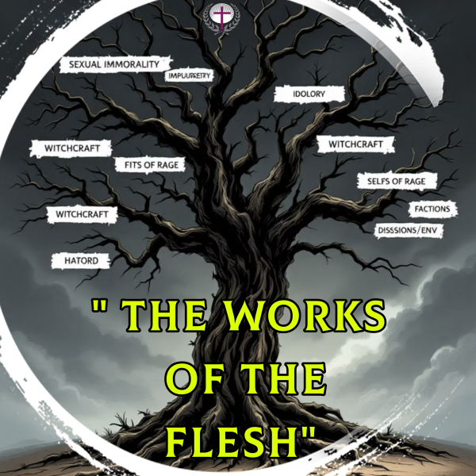

“¹⁹ Now the works of the flesh are manifest, which are these; Adultery, fornication, uncleanness, lasciviousness, ²⁰ Idolatry, witchcraft, hatred, variance, emulations, wrath, strife, seditions, heresies, ²¹ Envyings, murders, drunkenness, revellings, and such like: of the which I tell you before, as I have also told you in time past, that they which do such things shall not inherit the kingdom of God” - Galatians 5:19-21

SINS OF HOSTILITY - Hatred, Variance, Emulations, Wrath, Strife, Seditions, Heresies, Envyings, and Murders.

WORK # 15: MURDERS

In Galatians 5:19-21, the Apostle Paul provides a comprehensive list of “works of the flesh”– sinful behaviors that stem from our fallen human nature. Among these serious transgressions, Paul mentions explicitly “murders.”

Biblical Definition: The Greek word “phonos” primarily means murder or slaughter and is used eight other times in the New Testament. It refers to the deliberate taking of a human life. In some contexts, it can also refer to homicide or killing in a broader sense.

Murder in Scripture: Beyond Physical Killing

In Matthew 15:19, Jesus identifies murder as one of the evils that proceed from the heart, defiling a person: “For out of the heart come evil thoughts, murders, adulteries, fornications, thefts, false witness, slanders.”

This teaching reveals that murder isn't merely an external action but originates from corrupted internal desires and thoughts. Jesus consistently emphasized the condition of the heart as the true source of both righteous and sinful behavior. His radical reinterpretation of the Law pointed to the inner person, where motivations and intentions reside.

By listing “murders” alongside “evil thoughts,” Jesus highlights a crucial spiritual truth: the journey to the physical act of taking a life often begins with destructive mental and emotional states. It's a progression from the unseen malice within to the visible transgression, underscoring the profound importance of cultivating a pure heart.

The apostle John further deepens our understanding in 1 John 3:15: “Everyone who hates his brother is a murderer; and you know that no murderer has eternal life abiding in him.” This profound insight establishes that in God's eyes, harboring hatred equates to murder. John’s words strip away any superficial understanding of murder, revealing it as a lack of love for another.

The declaration that “no murderer has eternal life abiding in him” emphasizes the seriousness of such spiritual hostility. It indicates that a heart constantly filled with hatred is fundamentally incompatible with the life and nature of Christ, which is marked by self-sacrificial love. This spiritual condition prevents genuine fellowship with God, who is love.
Murderous attitudes poison relationships long before any physical violence occurs. They destroy trust, cooperation, and community—all values central to Christian fellowship.

Murder, in its full biblical scope, is both a physical act and a corrosive condition of the heart. The Scriptures consistently treat it as a profound manifestation of our fallen nature's most destructive impulses, emphasizing that true life in Christ necessitates a transformation of both outward behavior and inner disposition.

Galatians 5:19-21 reveals that murder doesn't exist in isolation but is connected to other works of the flesh:
- Hatred provides the emotional foundation.
- Jealousy and envy supply the motive.
- Outbursts of wrath precede the action.
- Selfish ambitions justify the deed.

Cain and Abel: The First Murder and the Battle Within (Genesis 4:1-13)
The very first murder recorded in scripture demonstrates a profound spiritual principle: violent actions begin as destructive thoughts. Cain's killing of Abel wasn't merely an impulsive act, but the culmination of jealousy, anger, and unaddressed bitterness that festered in his heart. Their story reveals the universal human struggle against the darkness within.
A Tale of Two Brothers
- Cain and Abel, sons of Adam and Eve, bring offerings to God
- God favors Abel's sacrifice but rejects Cain’s.
  - “⁴ And Abel, he also brought of the firstlings of his flock and of the fat thereof. And the Lord had respect unto Abel and to his offering: ⁵ But unto Cain and to his offering he had not respect. And Cain was very wroth, and his countenance fell” - Genesis 4:4-5.
- Cain's face falls; God warns him.
  - “And the Lord said unto Cain, Why art thou wroth? and why is thy countenance fallen? ⁷ If thou doest well, shalt thou not be accepted? and if thou doest not well, sin lieth at the door. And unto thee shall be his desire, and thou shalt rule over him”- Genesis 4:6-7.
This pivotal moment of divine discernment sets the stage for humanity's first murder. Cain’s act was not an impulsive rage but the result of jealousy, anger, and unaddressed bitterness in his heart. God even warned him, “Sin is crouching at your door; it desires to have you, but you must rule over it” - Genesis 4:7.

  - Cain was jealous of his brother. His rejection fueled a deep envy of his brother's divine favor and acceptance.

  - Cain became angry—his resentment manifested physically—“his countenance fell…”—revealing the emotional turmoil within.
  - Cain became bitter towards his brother. Over time, these feelings festered into a hardened heart that rejected God's warning.
God's Warning: The Choice to Master Sin

  - “Sin is crouching at your door; it desires to have you, but you must rule over it” - Genesis 4:7.
  - This profound divine warning, delivered directly to Cain by God Himself, came at a critical juncture – before the tragic act. It reveals not only God's foresight but also His desire to guide Cain toward a path of righteousness. It underscores three crucial and timeless truths:
        - Sin as a Cunning Predator. - Sin is portrayed as a cunning predator: The imagery of sin “crouching at your door” vividly depicts it as a wild beast, lurking, waiting patiently for the opportune moment to ensnare its prey.

        - Sin’s desire to control - The text clearly states that sin “desires to have you.” This personification highlights sin's deceptive allure and its ultimate goal: to dominate, enslave, and lead individuals down a destructive path, usurping their will and actions.

        - Human Capacity to Overcome - Crucially, God immediately follows with the command, “but you must rule over it.” This means we have the power to choose. Cain, and all of us, have free will to choose to do what is right, even when sin tries to pull us away. We are called to be in charge, not to be victims.

          - See Romans 6:14 and Titus 2:11-12.

The Tragic Outcome: Murder as the Fruit of Unaddressed Sin
Deception | The Act | Confrontation and Consequences
“Cain said to Abel, 'Let's go out to the field'” -Genesis 4:8.  A premeditated act of deception shows the calculated nature of his sin. | While in the field, Cain violently attacked Abel and killed him (Genesis 4:8).  This irreversible act was the tragic culmination of the jealousy, anger, and bitterness that Cain allowed to fester in his heart, ignoring God's warning. | God immediately confronted Cain, asking, “Where is your brother Abel?” (Genesis 4:9), to which Cain defiantly replied, “Am I my brother's keeper?”  “Now you are under a curse and driven from the ground...” (Genesis 4:11)  Cain's sin led to exile, separation, and a life of wandering.

Warning Signs of Festering Jealousy:

- Preoccupation with others' success or blessings.

- Inability to celebrate the achievements of peers.

- Persistent negative thoughts about specific individuals.

- Physical manifestations like Cain's “fallen face.”

The Practical Step for Overcoming the Propensity to Murder is Loving One Another.
Jesus established love as the defining characteristic of His followers in John 13:34-35: “A new commandment I give unto you, That ye love one another; as I have loved you, …By this shall all men know that ye are my.”
- Family Relationships- Practice intentional forgiveness within your family. Address conflicts quickly rather than allowing resentment to grow. Remember Paul's instruction: “Do not let the sun go down on your anger” - Ephesians 4:26.

- Church Community - Actively seek reconciliation with fellow believers when tensions arise. Speak the truth in love rather than harboring grievances. “If possible, so far as it depends on you, be at peace with all men”-Romans 12:18.

- Difficult Relationships- Follow Jesus' radical teaching to “love your enemies and pray for those who persecute you”- Matthew 5:44. This supernatural love directly counters the murderous tendencies of the flesh.
Call to Action: Choose the Spirit Over the Flesh
- Heart Examination - take time this week for prayerful self-examination. Ask the Holy Spirit to reveal any hatred, rage, or contempt in your heart toward others. Use Psalm 139:23-24 as your prayer: "Search me, O God, and know my heart; try me and know my anxious thoughts; and see if there be any hurtful way in me."

- Daily Spirit-Walking - Commit to intentionally “walking in the Spirit” each day through prayer, Scripture meditation, worship, and obedience. Begin each morning by surrendering your thoughts and emotions to God's control, especially in challenging relationships.

- Love in Action - Identify one person who is difficult to love—perhaps someone who has hurt you or with whom you have ongoing conflict. Pray for them daily and find one practical way to show Christ's love to them this week, regardless of how they respond.

NOTES
………………………………………………………………………………………………………………………………………………………………………………………………………………………………………
………………………………………………………………………………………………………………………………………………………………………………………………………………………………………
………………………………………………………………………………………………………………………………………………………………………………………………………………………………………
………………………………………………………………………………………………………………………………………………………………………………………………………………………………………
………………………………………………………………………………………………………………………………………………………………………………………………………………………………………

